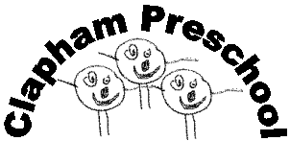Clapham Preschool (Bedford)

Our Sickness Policy

Our policy for the exclusion of ill or infectious children is discussed with parents/carers. This includes procedures for contacting parents/carers – or other authorised adults – if a child becomes ill while in the setting.

- We do not provide care for children who are unwell, have a temperature, or sickness and diarrhea, or who have an infectious disease.

- If a child or staff member has suffered from any diarrhoea and/or vomiting, they must not attend the setting until they have been symptom free for 48 hours.

- If a child becomes ill during a session, every attempt will be made to contact one of the person listed on the child’s profile on the Blossom App, to arrange collection of the sick child. The child will be cared for until collected.

- If a child or staff member has a communicable disease, (other than HIV or Hepatitis B) they should not attend the setting until they are no longer infectious.

- Ofsted will be notified of any infectious diseases that a qualified medical person considers notifiable.

- Children with head lice are not excluded, but must be treated to remedy the condition.

- Children and families are not excluded because of HIV.

- If a member of staff becomes ill during a session, adequate staff cover will be organised enabling the staff member to go home. If they require assistance, contact will be made with the necessary person, who will be able to assist the staff member to travel home.

This Policy was adopted at a meeting of Clapham Preschool held on …………………………

Signed on behalf of the Preschool …………….………………………………………………..

Reference made to:

2021 Early Years Foundation Stage Statutory Framework.

